## **MATLAB Programming Lesson 1: Getting Started with MATLAB**

## Objectives

* **Variables and Operators:**Understand how to use variables, built-in functions, and constants.
* **Debugging:** Be able to debug code
* **Arrays:**Create and utilize arrays
* I**ndexing:** Index and modify arrays
* **Calculations:** Perform calculations on arrays

## Main Learning Goal

Students will learn the basics of MATLAB and its interface, such as how to use variables and functions. They will also learn how errors can occur and how to debug them. Finally, students will learn how to create, modify, and utilize arrays in a variety of ways.

## Focus Question

How can programmers use MATLAB to store data and create meaningful outputs?

## How Can We Use Programming to Predict Sports and Top Tracks?

**Let’s look at this video about using programming to predict a player’s performance in the NBA:**

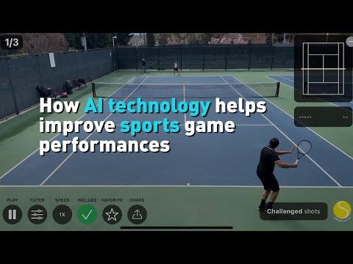

Link: <https://www.youtube.com/watch?v=B99egqUoP1s>

**After watching this video, let’s discuss the following questions:**

1. Tools like the one in this video need a lot of data to be trained on. Why do you think getting plenty of data is important for making good predictions?
2. How do you think programs like these store different types of data? Would a player’s name be stored in a different way than player’s average score per game (name vs. number)?
3. What other places could you apply a tool like this? How might something like this be useful for working in the music industry?

**Let’s see how the music industry compares to sports and what kind of data they look at when making predictions:**

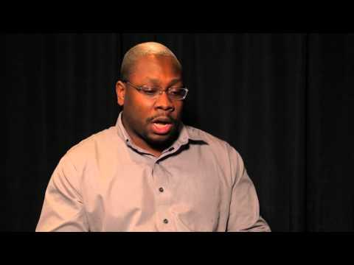

Link: <https://www.youtube.com/watch?v=lqG7MyCnXWA>

**Let’s discuss:**

How does the music industry differ from the sports industry? For sports the focus is on the athlete, but is music solely data generated by the artists?

## Coding Part 1: Getting Started!

**Before getting started with today’s coding, here are a few videos on how to create your account and access the files you will need to code:**

1. **Please watch this tutorial on how to create a MathWorks Account:** [**https://youtu.be/kwNFpoY3dKk**](https://youtu.be/kwNFpoY3dKk)

**You will be using this link to access the folder with the files for this Lesson:**

[**[Please Click Here]**](https://drive.mathworks.com/sharing/69b123f0-5eb1-4d9e-9a64-f14498986d9f)

1. **Please watch this tutorial on how to use the MATLAB Drive to access the files for this section:** [**https://youtu.be/Ap9fqfN1ioA**](https://youtu.be/Ap9fqfN1ioA)

## **Please copy over the files for Section 01 from the MATLAB Drive**

**Remember that you may need to exit MATLAB by clicking your profile in the top right and re-opening the MATLAB online tool for the files to appear.**

When you copy over the files, you should see the Section 01 Folder, with two files in it. Please start with the Part 1 file, called ML_Sec01(Part_1)-GettingStarted_v2.mlx, here is an image of the folder and the files:A screen shot of a computer

**Here is an image of the first part of the live script:**

## **For this section, you will be following along with the explanations and completing the “Now You Try!” examples and experimenting with the code blocks.**

## **Please follow along with explanations from the teacher or use the PowerPoint to guide you through the live script, one step at a time. You can find the PDF of the PowerPoint in the same folder as your live scripts:** [**[Please Click Here]**](https://drive.mathworks.com/sharing/69b123f0-5eb1-4d9e-9a64-f14498986d9f)

## **After completing the final example using data on Stephen Curry, you can continue to Part 2 where you will complete an activity using some data on some top music tracks.**

## Coding Part 2: Using Data In Music

**You will now open the second live script in the folder on your MATLAB Drive, called ML_Sec01(Part_2)-DataInMusic.mlx:**

**Please follow along with the explanations in the live script and/or the PDF of the PPT inside the MATLAB Drive folder.**

**You've been hired by a record label in order to organize their artist's data (a company that publishes artist's music and promotes it). The company has given you 3 tasks to complete. Once you complete the third, feel free to try the extra example as well!**

## Choosing the Parameters That Matter

**Now that we have got some practice with both sports and music data, think about the videos that we watched at the beginning of this lesson about predicting the success of an athlete or the next hit song.**

**Let’s complete the following activity:**

1. Get together with a group or partner and choose whether you want to predict the next best athlete (and what sport they play), or whether you want to predict the next hit song.
2. Think about what parameters (variables) and what types of data you need to focus on and collect. (Is it the number of goals, the number of streams? Are these numerical values like doubles or strings?)
3. Create a list of the top 5 most important parameters for your prediction and include why it is important. (feel free to add more than 5!)
4. Share your parameters with the class!

